

Scotch College
Semester One Examination, 2010

Question/Answer Booklet

MATHEMATICS
3C/3D Specialist
Section Two:
Calculator-assumed

Teacher:
Mr Hill
Mr Robb

Name:

Time allowed for this section
Reading time before commencing work: 10 minutes
Working time for this section: 100 minutes

Material required/recommended for this section

To be provided by the supervisor
This Question/Answer Booklet
Formula Sheet (retained from Section One)

To be provided by the candidate
Standard items: pens, pencils, pencil sharpener, eraser, correction fluid, ruler, highlighters

Special items: drawing instruments, templates, notes on two unfolded sheets of A4 paper, and up to three calculators satisfying the conditions set by the Curriculum Council for this examination

Important note to candidates
No other items may be taken into the examination room. It is your responsibility to ensure that you do not have any unauthorised notes or other items of a non-personal nature in the examination room. If you have any unauthorised material with you, hand it to the supervisor before reading any further.

Structure of this paper

Section | Number of questions available | Number of questions to be answered | Working time (minutes) | Marks  available
Section One:  Calculator-free | 6 | 6 | 50 | 40
Section Two  Calculator-assumed | 12 | 12 | 100 | 80
 |  |  |  | 120

Instructions to candidates

1. Write your answers in the spaces provided in this Question/Answer Booklet. Spare pages are included at the end of this booklet. They can be used for planning your responses and/or as additional space if required to continue an answer.
  - Planning: If you use the spare pages for planning, indicate this clearly at the top of the page.
  - Continuing an answer: If you need to use the space to continue an answer, indicate in the original answer space where the answer is continued, i.e. give the page number. Fill in the number of the question(s) that you are continuing to answer at the top of the page.

2. Show all your working clearly. Your working should be in sufficient detail to allow your answers to be checked readily and for marks to be awarded for reasoning. Incorrect answers given without supporting reasoning cannot be allocated any marks. For any question or part question worth more than two marks, valid working or justification is required to receive full marks. If you repeat an answer to any question, ensure that you cancel the answer you do not wish to have marked.

3. It is recommended that you do not use pencil except in diagrams.

Section Two: Calculator-assumed (80 Marks)

This section has twelve (12) questions. Answer all questions. Write your answers in the space provided.

Spare pages are included at the end of this booklet. They can be used for planning your responses and/or as additional space if required to continue an answer.
  - Planning: If you use the spare pages for planning, indicate this clearly at the top of the page.
  - Continuing an answer: If you need to use the space to continue an answer, indicate in the original answer space where the answer is continued, i.e. give the page number. Fill in the number of the question(s) that you are continuing to answer at the top of the page.

Suggested working time for this section is 100 minutes.

1. [5 marks]

Display the following on the single Argand Diagram below.

(a) 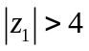 [2]

(b) 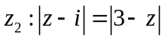 [3]

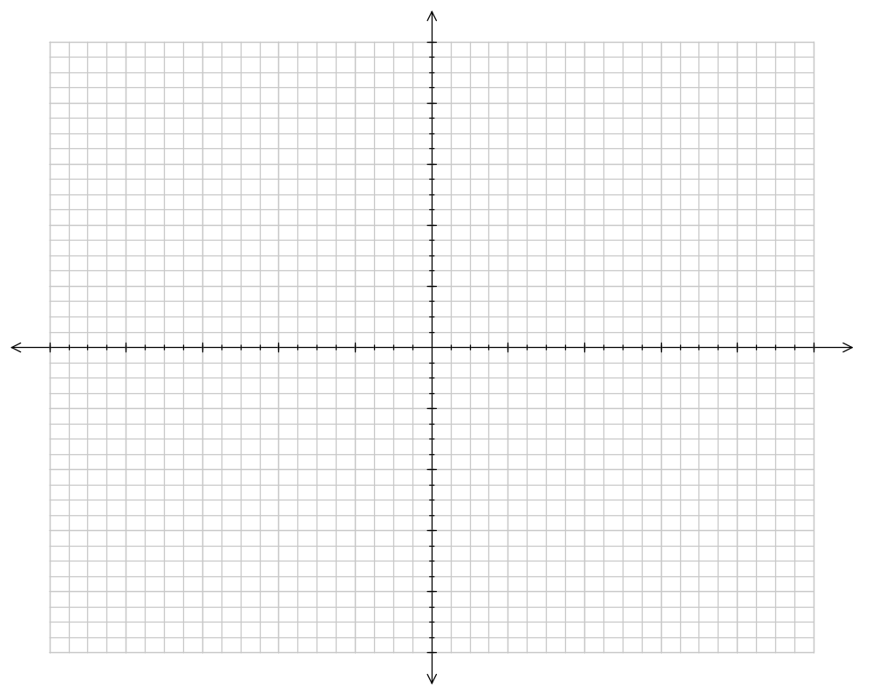

2. [4 marks]

Consider the matrix 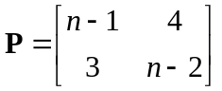

  - Find the det(P) and hence find values of n such that det(P) = 0 [3]

  - State the conditions that would allow 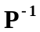 to exist. [1]

3. [5 marks]

Point A has polar co-ordinates 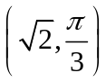 and point B 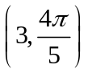
(a) Determine the distance between A and B. [2]

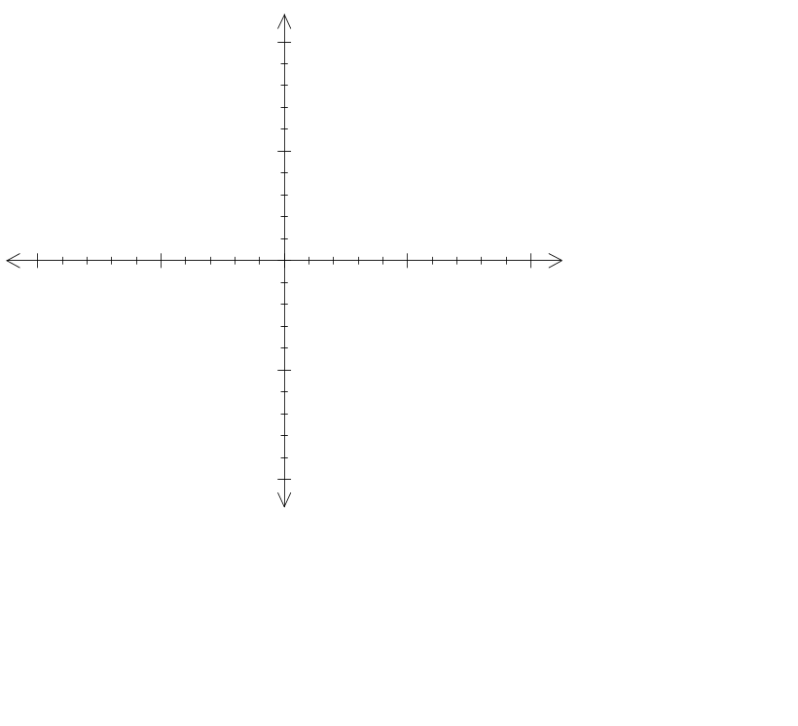(b) If the point A lies on the line 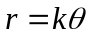, determine k and hence sketch the graph for 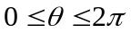. [3]

4. [7 marks]

Using the substitution provided, solve the following integral. Show full working.

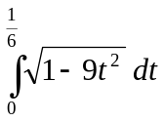 let 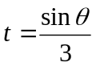

5. [6 marks]

- On the following axes neatly sketch, for x > 0, the graphs y = x, 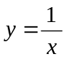and the lines 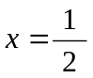and x = 2. Hence, shade the region(s) trapped between the graphs of y = x, and the lines and x = 2. [2]
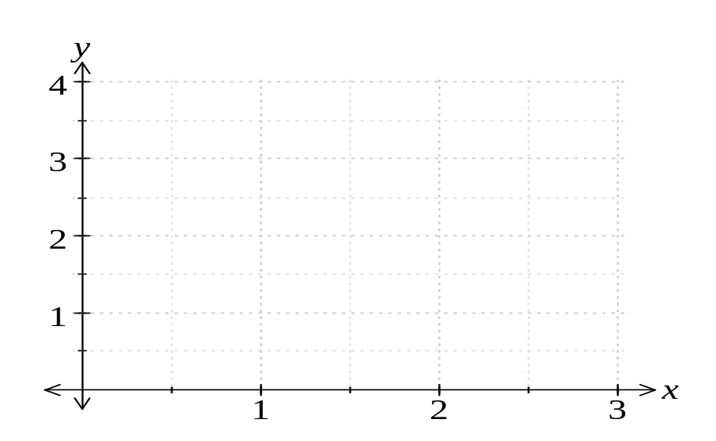
- Complete the following expressions for the total area of the region shaded. No integrals may be added to the expression and all integrals shown are to be used. [3]

- 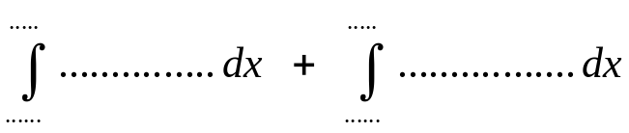

- 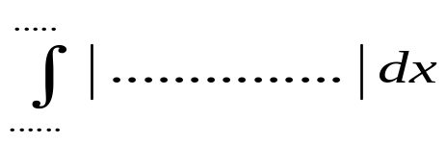

- 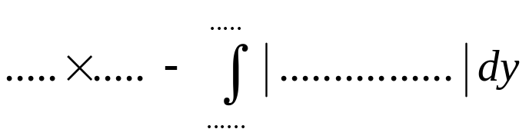
- Calculate the total area of the region shaded. [1]

6. [6 marks]

(a) Find the vector equation of a line, 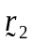 , passing through the point with position vector 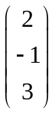 and perpendicular to the line 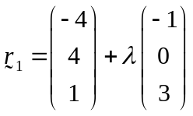 [2]

(b) Find any position vector(s) that lie on 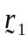 and have a length of magnitude 6. [4]

7. [6 marks]

The parametric equation of a curve is given as 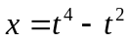and 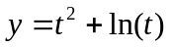. Find the equation of the tangent to this curve when t = 1.

8. [10 marks]

(a) By considering an integer n as either a multiple of 3 or 1 more than a multiple of 3 or 2 more than a multiple of 3;
Use proof by exhaustion to show than if n² is a multiple of 3 then n must also be a multiple of 3. [5]

(b) Use proof by contradiction to show that the square root of 3 is irrational.
(You may use your result from (a) ) [5]

9. [8 marks]

The Swanbourne Sweets Store started a promotion to sell three different boxes of a dozen mixed chocolates. Each mixed box contains different quantities of white, dark and milk chocolate. This information is shown in the following table.
 | Mixed G Box 1 | Mixed Box 2 | Mixed Box 3
Bottles of White | 8 | 6 | 4
Bottles o fDark | 2 | 2 | 4
Bottles of Milk | 2 | 4 | 4

Swanbourne Sweets purchases white chocolate for $11 per chocolate, dark chocolate for
$8 per chocolate and milk chocolate for $9 per chocolate.

Using P to represent the mixed box matrix and Q to represent the cost matrix, use matrix methods to answer the following, clearly indicating the matrix operation used .

  - Determine the matrix R which represents the cost to Swanbourne Sweets for a mixed dozen of each of the three varieties. [3]

  - One particular consumer orders eight mixed dozens of Box 1, five mixed dozens of Box 2 and six mixed dozens of Box 3. Find a matrix S showing the number of white chocolate, dark chocolate and milk chocolate Swanbourne Sweets requires to fill this order. [2]

(c) Swanbourne Sweets makes a profit of 24%, 30% and 40% on the sale of each chocolate of white, dark and milk respectively. Determine the sell price matrix T for each type of chocolate and hence the total amount paid by the customer for the order in part (b).
[3]

10. [7 marks]

(a) Show that the line 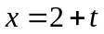, 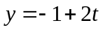, 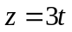 is parallel to the plane
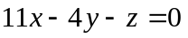. [4]

(b) Hence find the line’s distance from the plane. [3]

11. [6 marks]

A helicopter is descending towards level ground. It has a bright light directed vertically downwards such that the cone of light makes a circle on the ground.

30˚

The cone has a semi vertical angle of 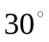, as shown . The helicopter descends at a constant rate of 3 m/sec. At what rate is the area of the circle changing when the helicopter is 8 m above the ground?

12. [10 marks]

(a) If 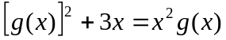 and 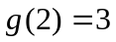, find 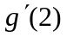. [4]

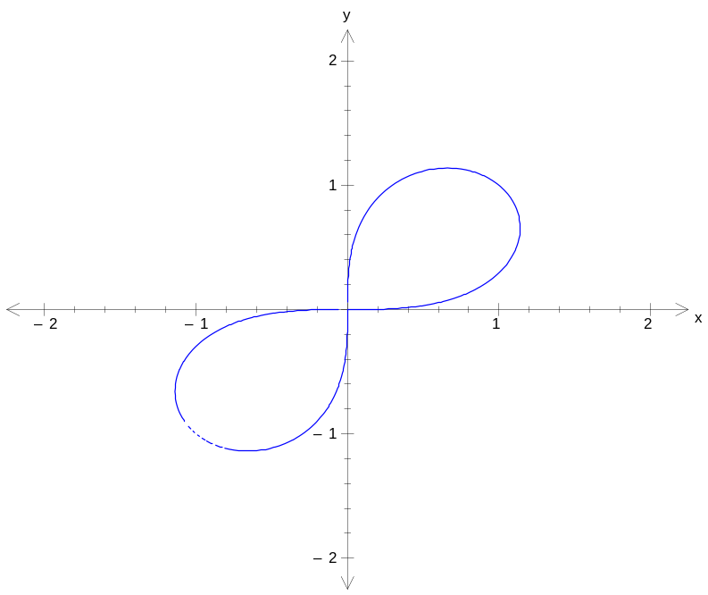(b) The graph of the equation 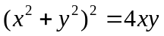 is called a lemniscate and is shown below. The points on the graph where the tangent is horizontal can be found when 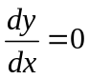. Use implicit differentiation and algebraic techniques to prove that these points are given by 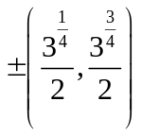. [6]

Additional working space

Question number(s):
Additional working space

Question number(s):

